AWS white paper is most valuable documentation for AWS.

Also this will provided information how we can migrate from our on-primses to AWS.

EC2 - Elastic Compute Cloud.

This can provide virtual machine on the cloud.

S3 - simple storage servers.

Just like “One Drive” or “Drop Box”

RDS - relational data base services.

So this will create DataBase on cloud and give its endpoints.

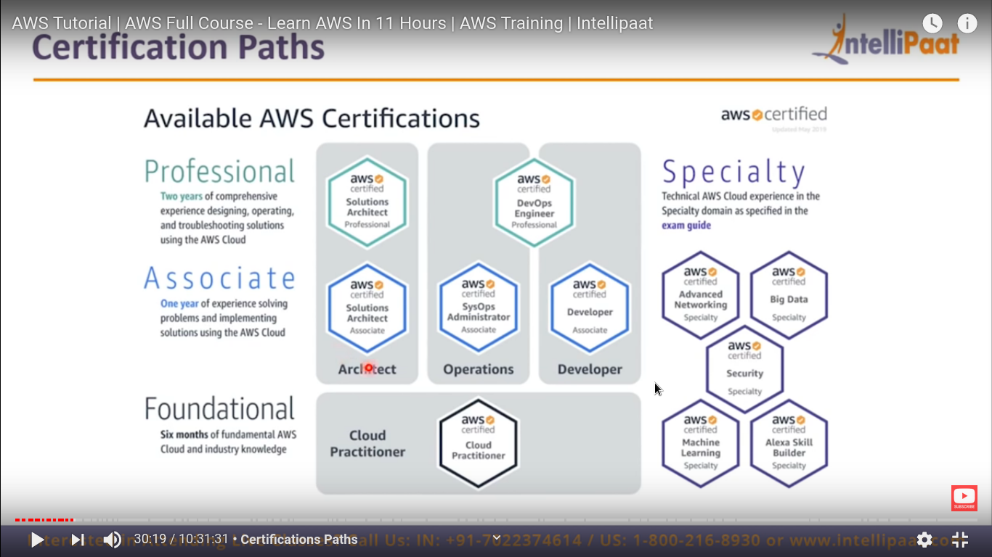

The basic is “Architecture” not much coding and other stuff required.

Here we just create infrastructure.

First we need to focus on “Associate solution Architecture”.

**AWS services:-**

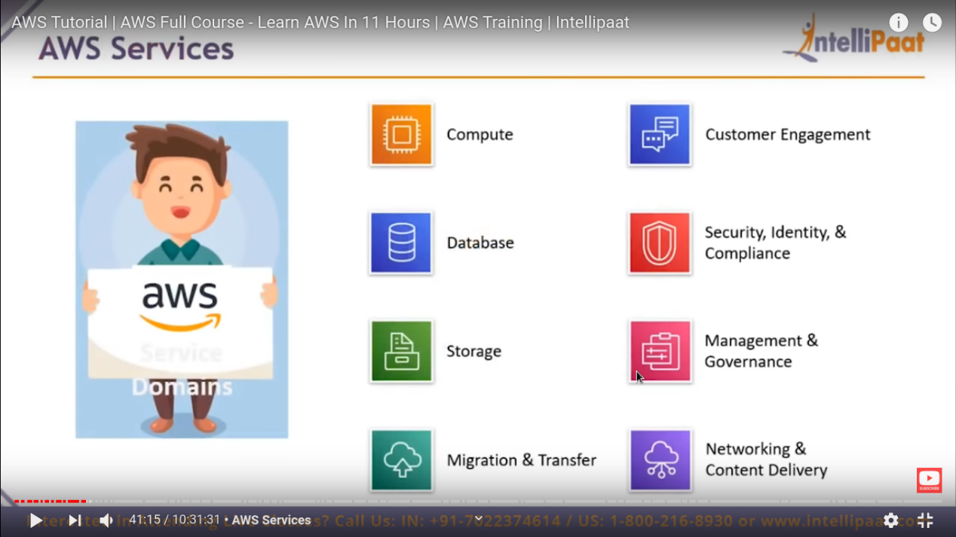

AWS services of some most used domains (there are more domain as well)

EC2 is most popular services available in AWS.

It is a virtual machine service.

It will give on demand scalable compute capacity in AWS cloud.

**RDS - relational database services**

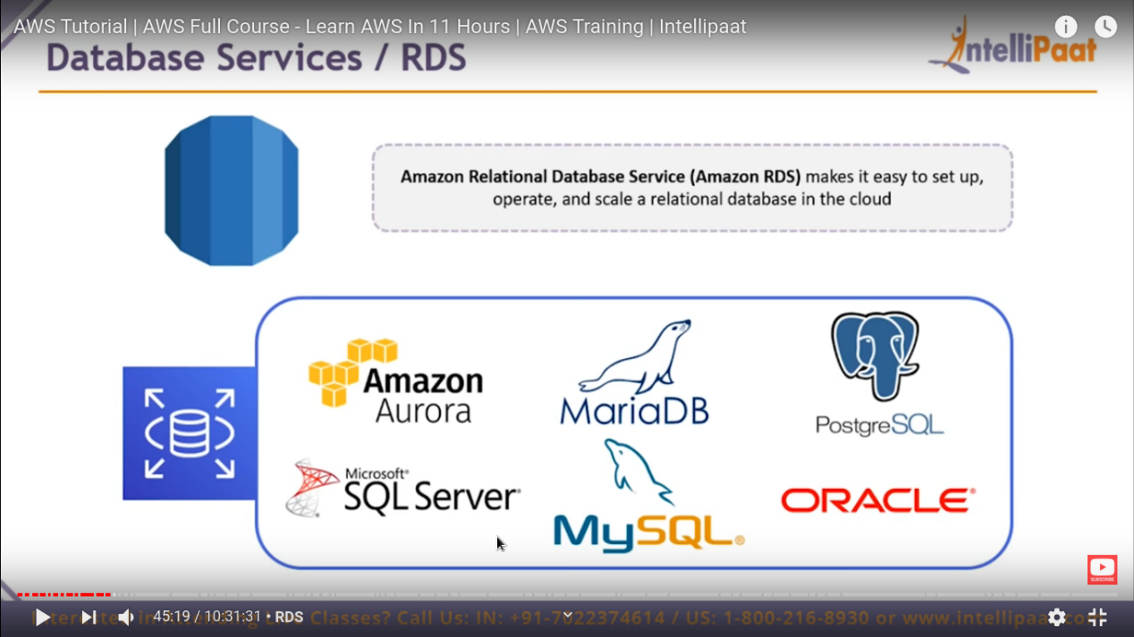

These are 6 database server that is provided by AWS.

Storage service (S3) :-

This is just like “google drive” , this is most used service after EC2.

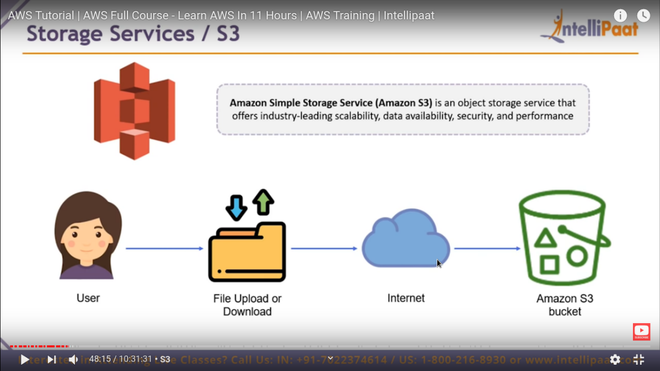

So it create “bucket” which is just like a folder .

This service is “CLOUD Front” this is actually a “networking service”.

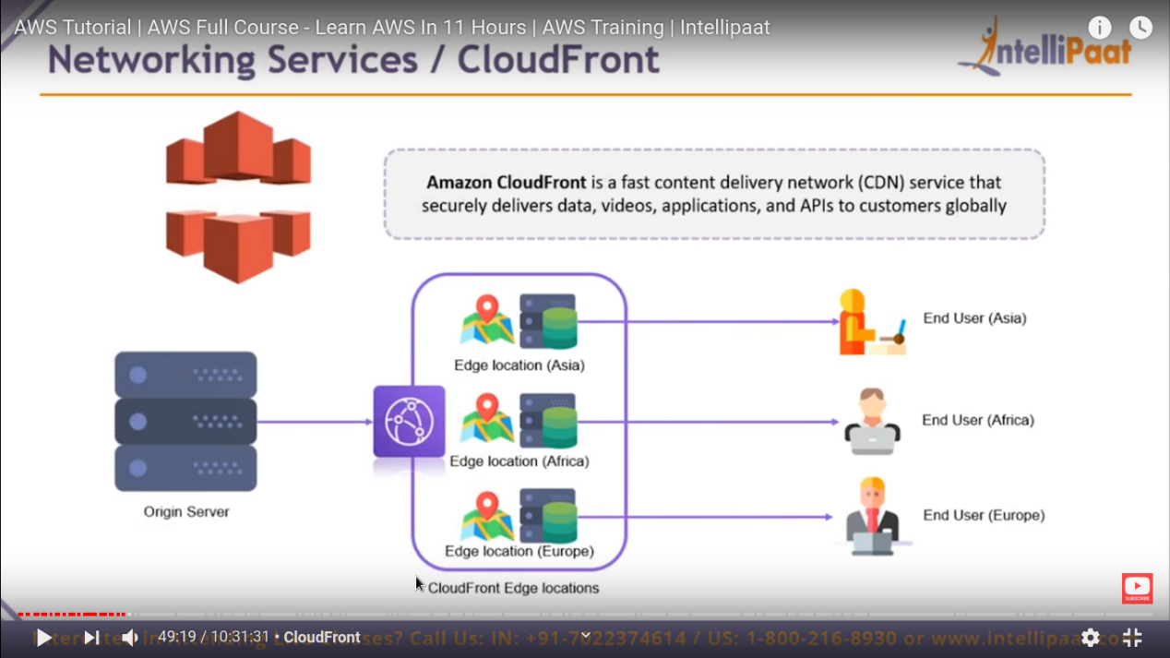

Amazon cloud Front is **CDN** content Delivery network.

Basically, CDN is a service by which we can securely and fast delivery of content like docs, image, video etc. And API to costumer globally.

**Security Service / IAM :-**

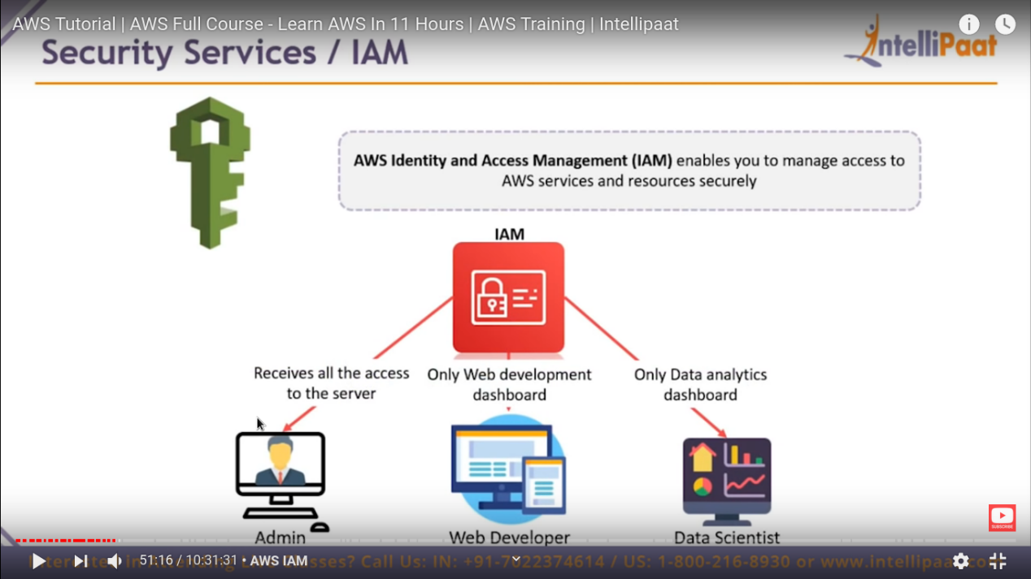

This service is called as identity and access management .

So for same account we have different user and different user have different access permission.

So that why we have service called IAM.

So, User can not go beyond those permission.

**Management Services/ CloudFormation / Infrastructure As Code :-**

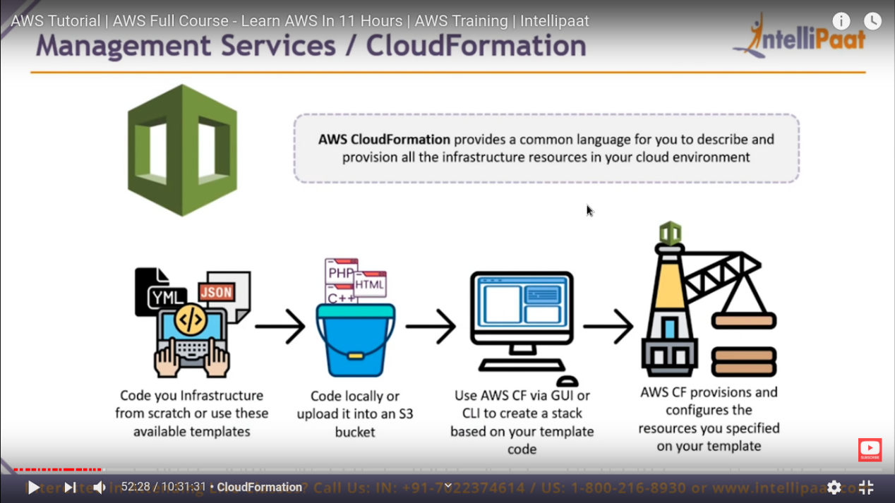

**How to create an AWS account:-**

Step 1:- go to your browser.

Step2:- http:// aws.amazon.com -> create a aws account -> fill form

Step3:- personal account -> fill all credit / debit card detail.

Step4:- select free tier account -> we can launch certain EC2 instances for free for one year for practice.

Step5:- go to sign-in page and just login.

Now go to management console , where you can get all services as per AWS offered

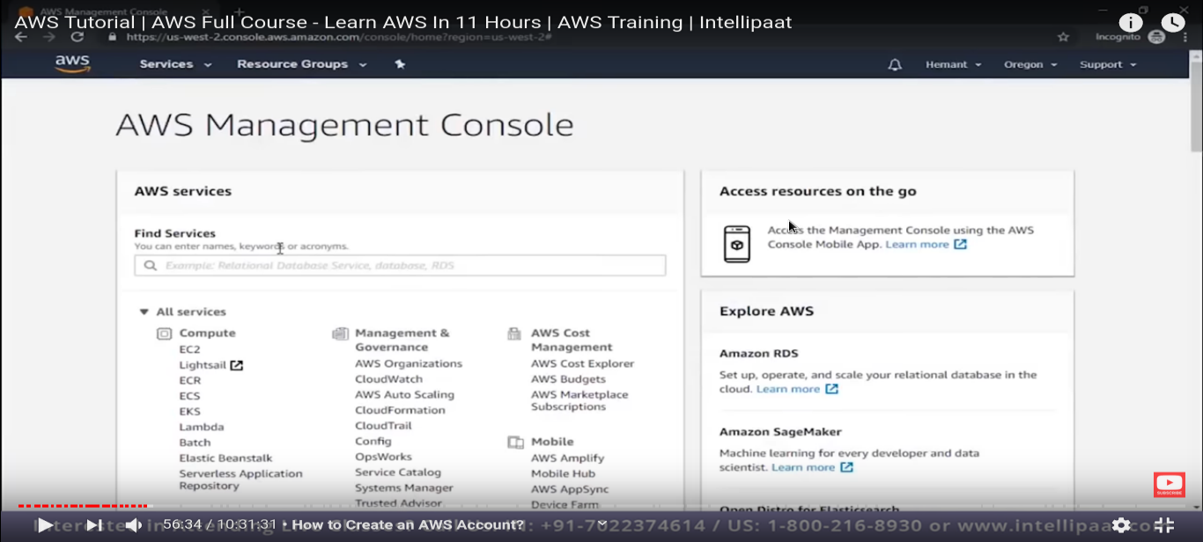

We are not going to view all the services as this is beyond our scope.

We are going to see only essential and mostly use services like EC2.

Now select EC2 (virtual server) :- this will leads to EC2 DashBoard.

From here we can launch our first EC2 instance.

Do not worried about all the option, we will see that later.

Till we are focus on “how we can launch our EC2 Instance”.

Just press the blue button   
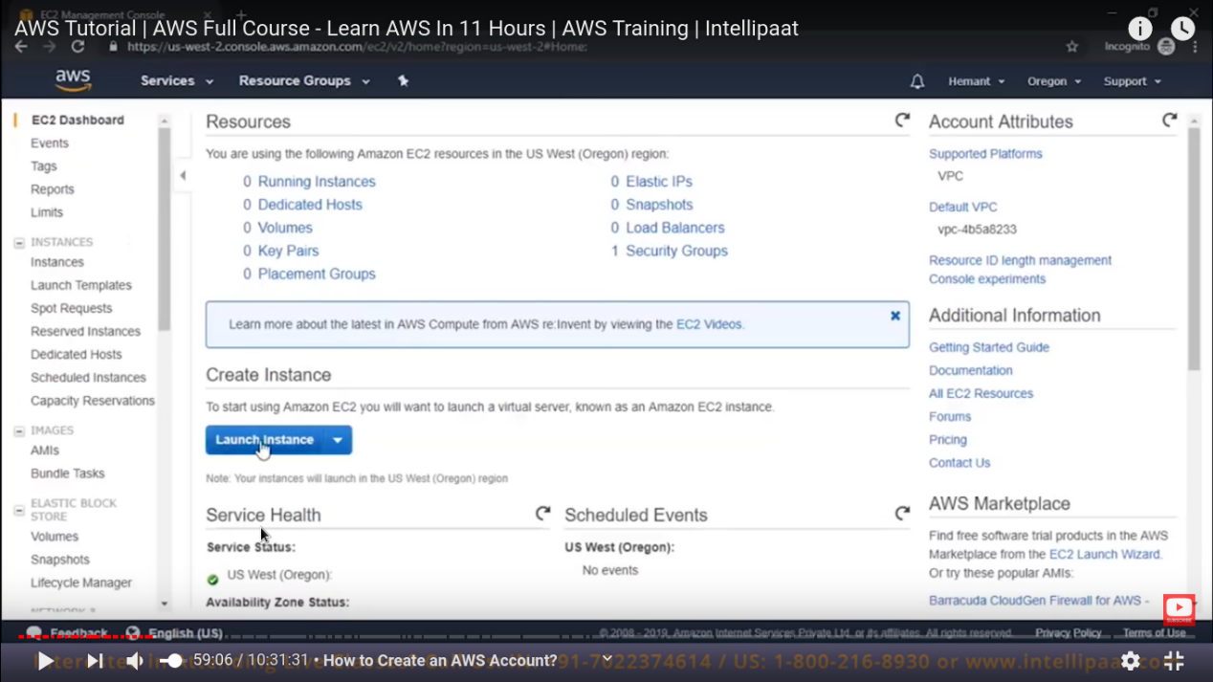

Then there will be a window come where you need to choose an operating system.

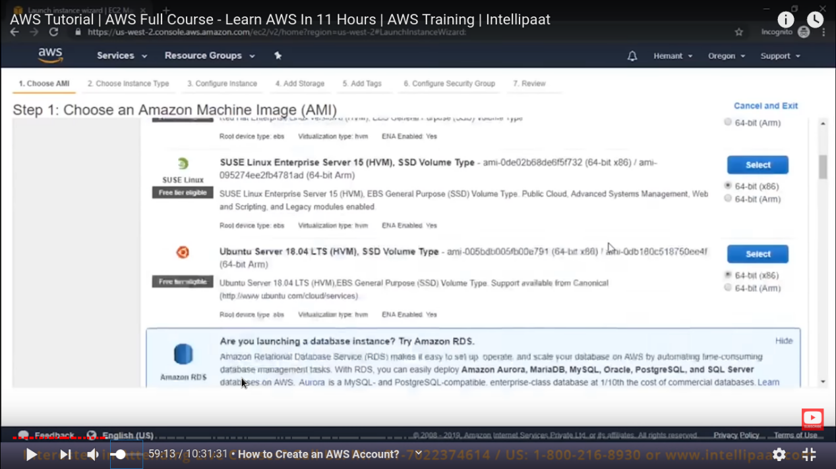

Select an operating system which you want to run on your server.

Please select only those operating which is showing free tier eligible.

After you select OS , now we need to define what size of server we want.

Here size actually means “memory” and “size”.

**Remember :-** the only EC2 that is free is “**t2.micro**” which is having cpu=1 and ram = 1gb .

Now click on next and we need to fill all other details as well.

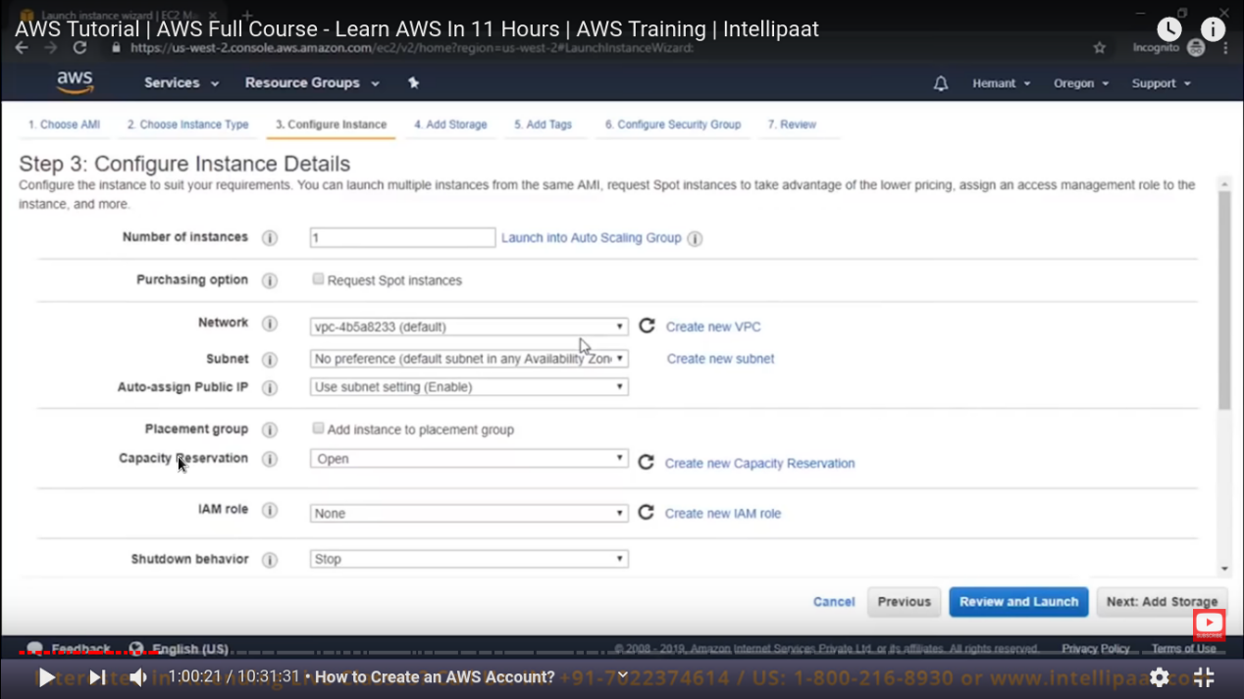

Currently do not worry about anything just leave it blank and click on “review and launch”

Now it will ask for harddrive storage

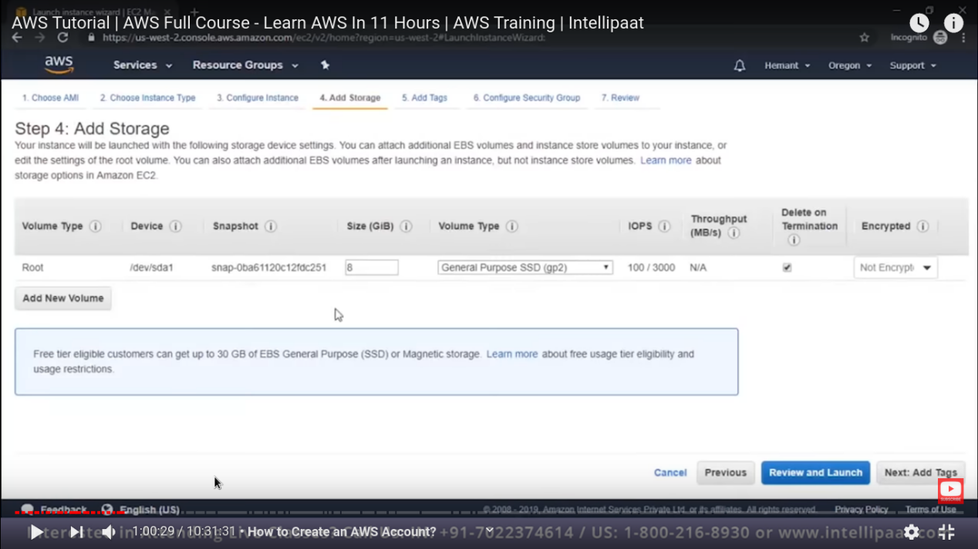

Leave it as default as we are just testing.

Now we can also add “tags”. tags are just like meta-data for our instance.

Like we can mention name of that instance , department to which this instance to which this instance belong like wise.

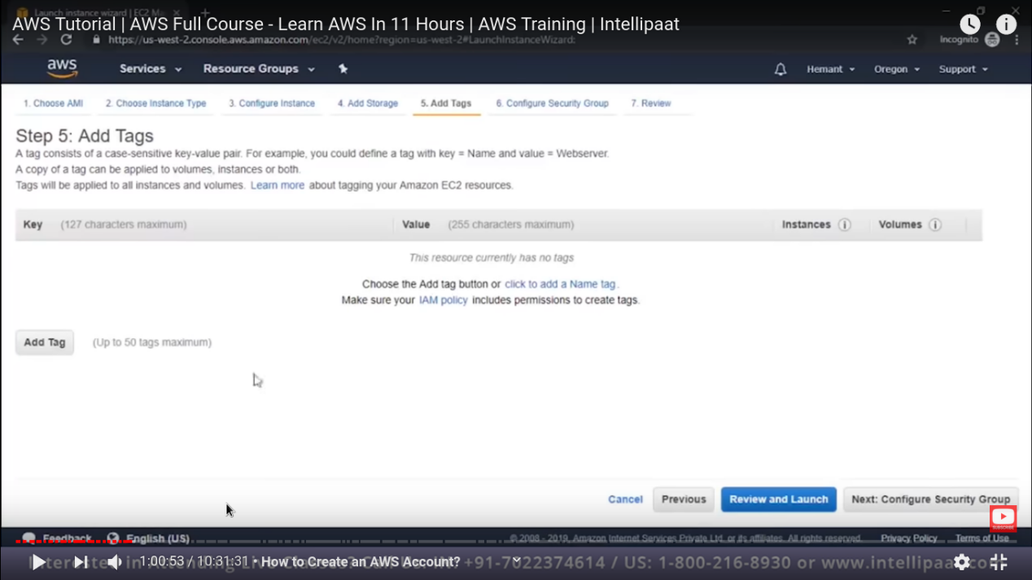

Now next -> it will leads to security group. Security group is just like a firewall.

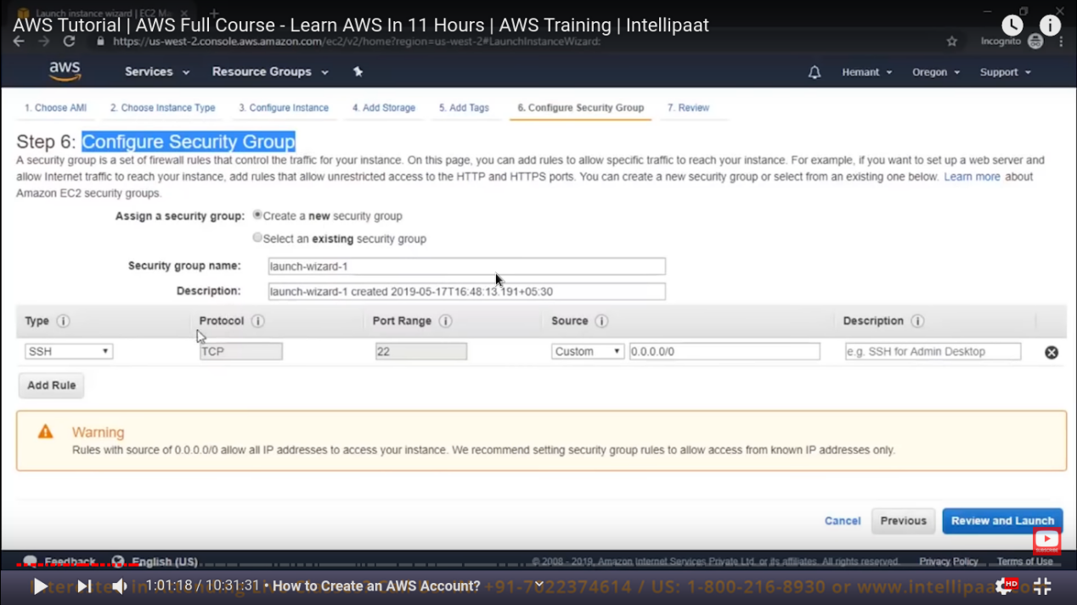

There are some kind of rules as well these are ‘’i**nbound**”. which tells that what kind of access can we take from the server like “ssh”.

For “ssh” we can also tell source to which we can access our server. Like from “anywhere”, or from “particular ip”.

Now click to “review and launch” -> now it time to review all the things.

Now when you click on “launch” this will show you a pop-up. Now here is important things we need to generate a key pair (generally a “pem” file).

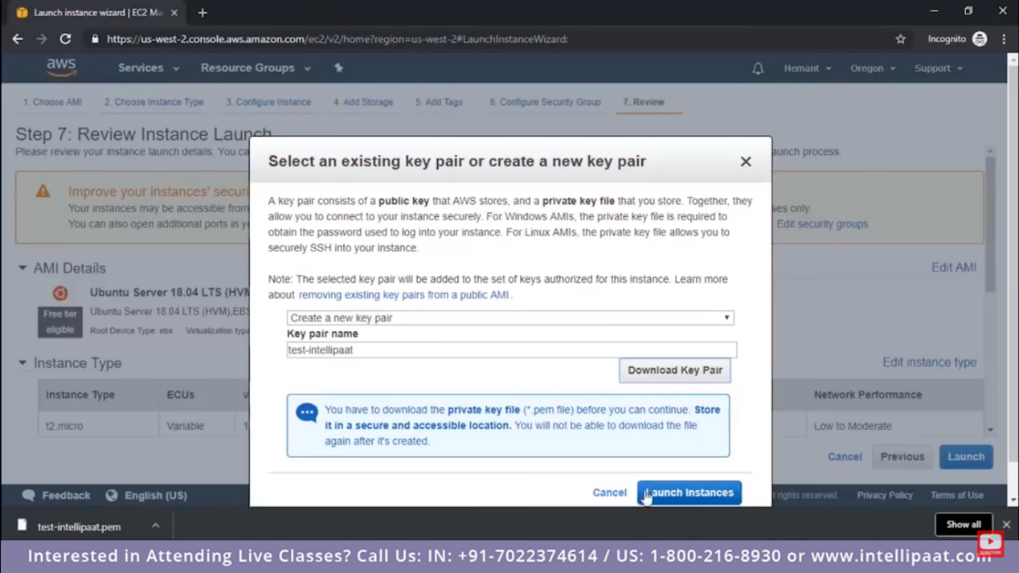

Mention key pair name and “Download key pair”. Here in above picture we can see the our “pem” file is downloaded.

Now click on “launch instance”.

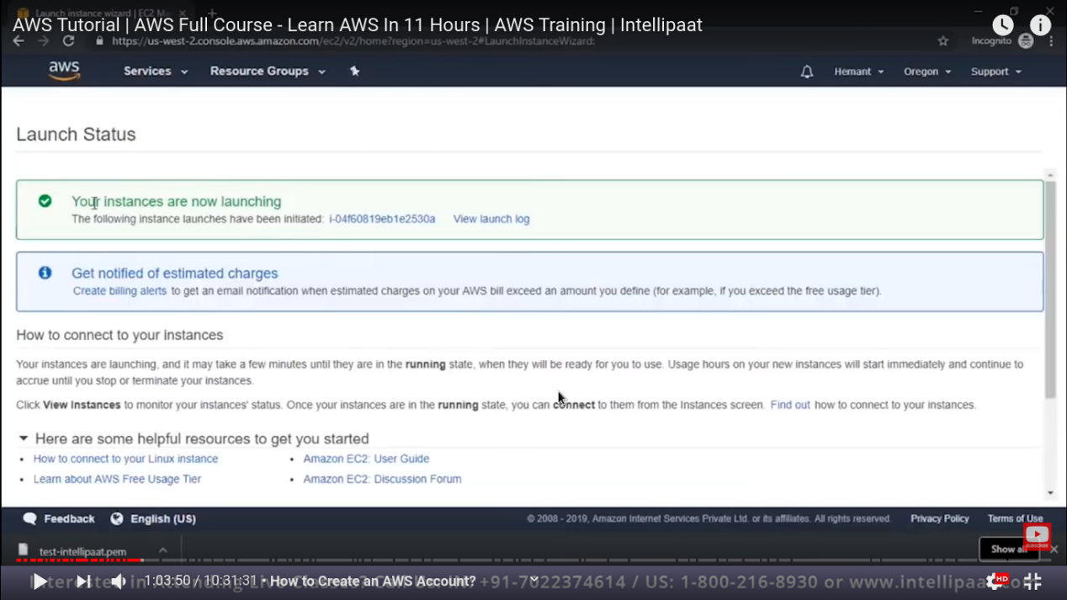

Now our instance is launching.

Just click on blue number-code to go to that instance

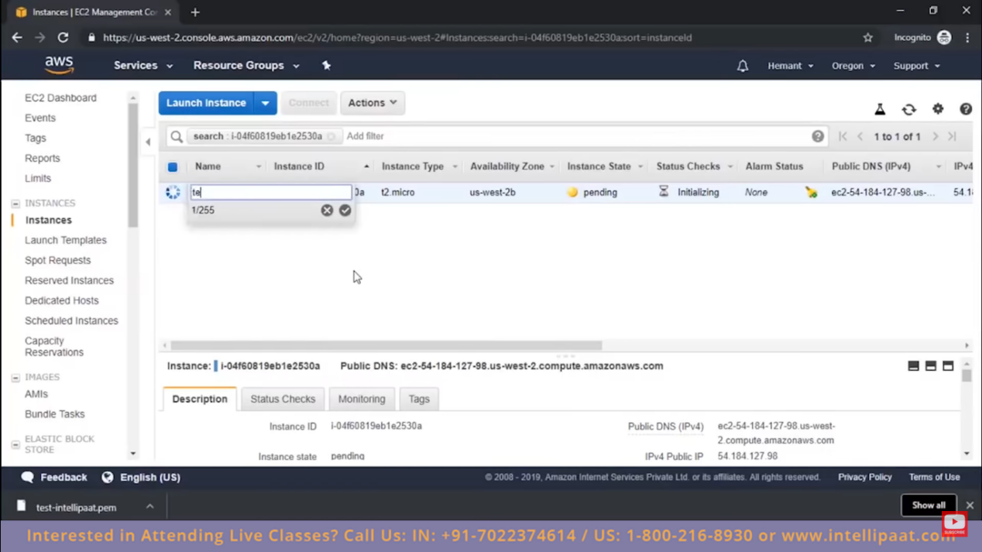

Here we can see that our instance is still pending and prepare for launching.

Here we can rename that instance as well.

In below pannel we can see the ip address and all other detail as well.

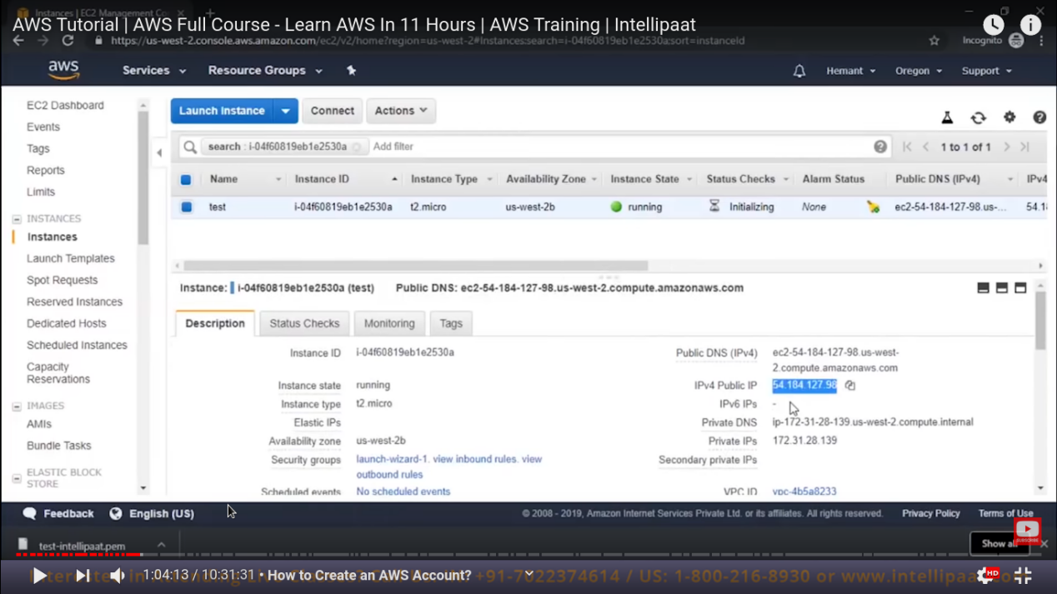

Now our instance is launch and the next step is to connect to that instance.

To connect to this instance we need to download two software:-

1. Putty
2. Puttygen

Puttygen is used to convert our “pem” file to ppkgen.

In puttygen -> load -> <our pem file> -> save private key (here our key is save as .ppk file)

Next step :- launch our putty software.

Give public ip address.

In putty -> ssh (left side down ) -> auth -> <select our .ppk file>

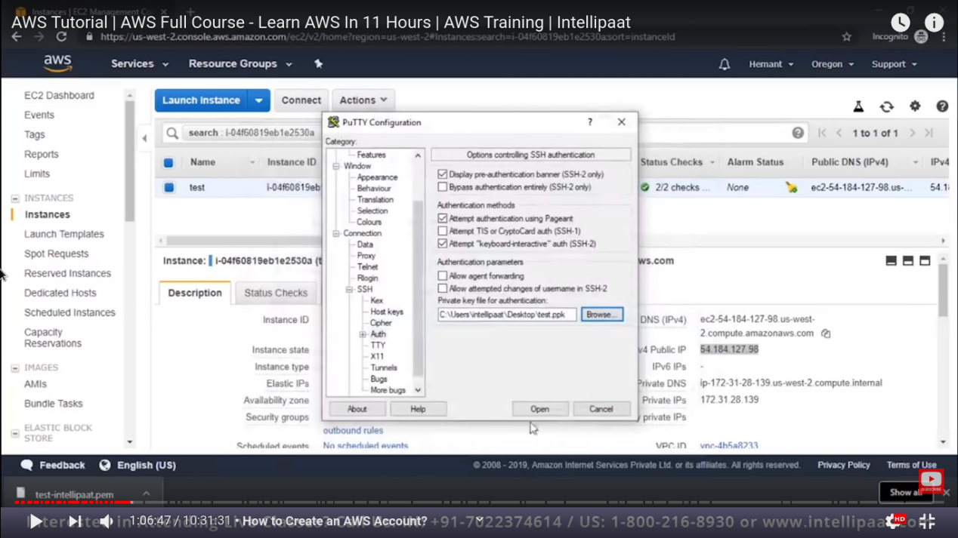

Now click on open.

Now as we have os as ubuntu so our username will be - “ubuntu”

Also because of our puttykeygen we dont required to enter password. We can login directly.

For windows you can not get a “pem” file. You will get a “rdp” file with password.

Now lets see the steps to launch windows instance.

Step1:- click on “launch Instance”

Step2:- windows os, which is free tier -> t2.micro -> next (leave all this as default)

Step3:- here for windows default size is 30GB.

Step4:- instead of “ssh” we have “rdp” because windows is gui based operating system.

Own launch our windows EC2 instance , when our instance is coming up .

Select that instance and “Action” -> “connect”.

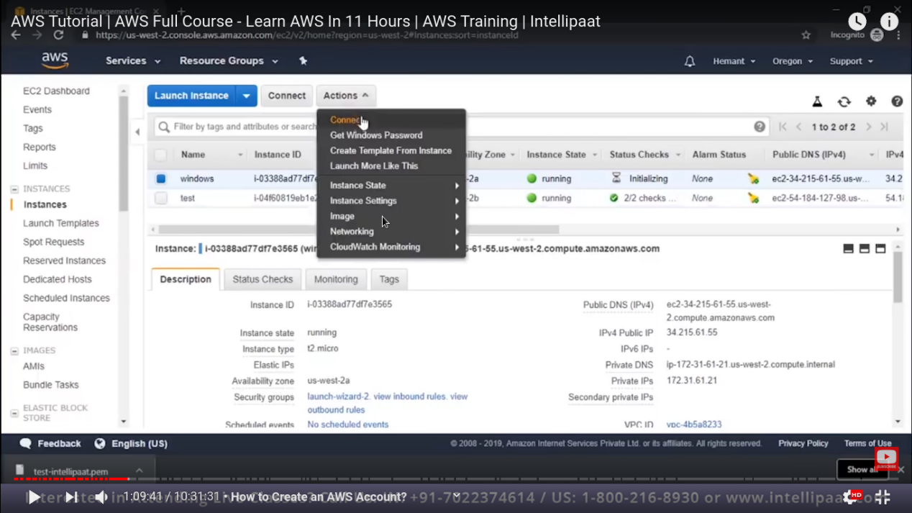

Now we can download the “rdp” file. And see your “username” and “password”.

Now directly click on the rdp file. And put username and password.

Also for password we can also go to “Action” -> “get windows password”.

Here we need to give our pem file (not .ppk file)

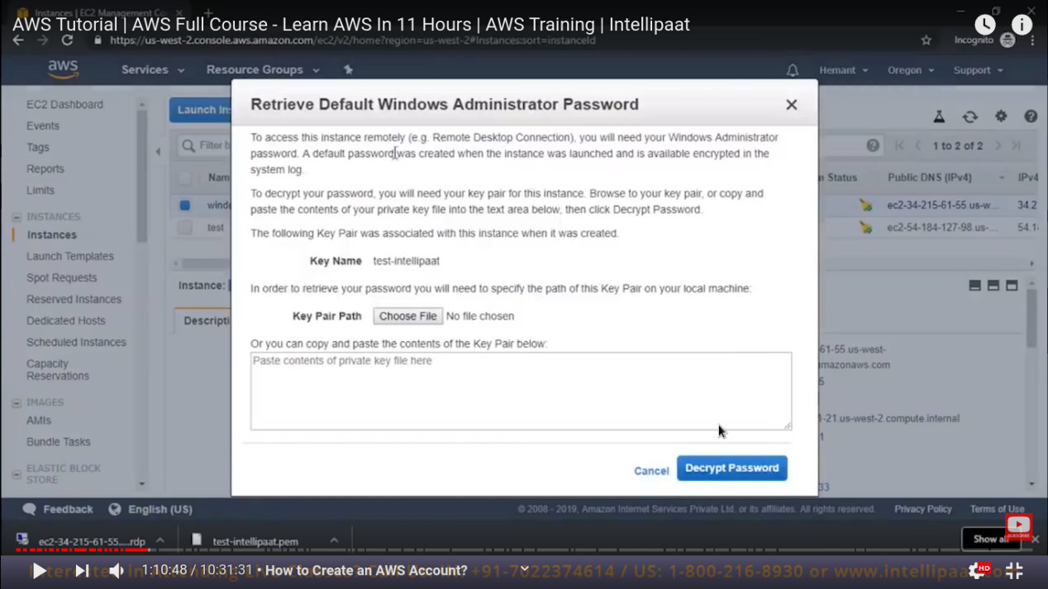

And once we give that pem file, we are now able to Decrypt Password.

Now by this we are able to get password.

So we are able to access our windows server.

Till now we have seen EC2 service.

Now lets jump to other service as well.

Click on the “aws” icon to go to other service as well.

Lets select “Elastic Beanstalk” service :-

Here is Dash board for “Elastic Beanstalk” :-

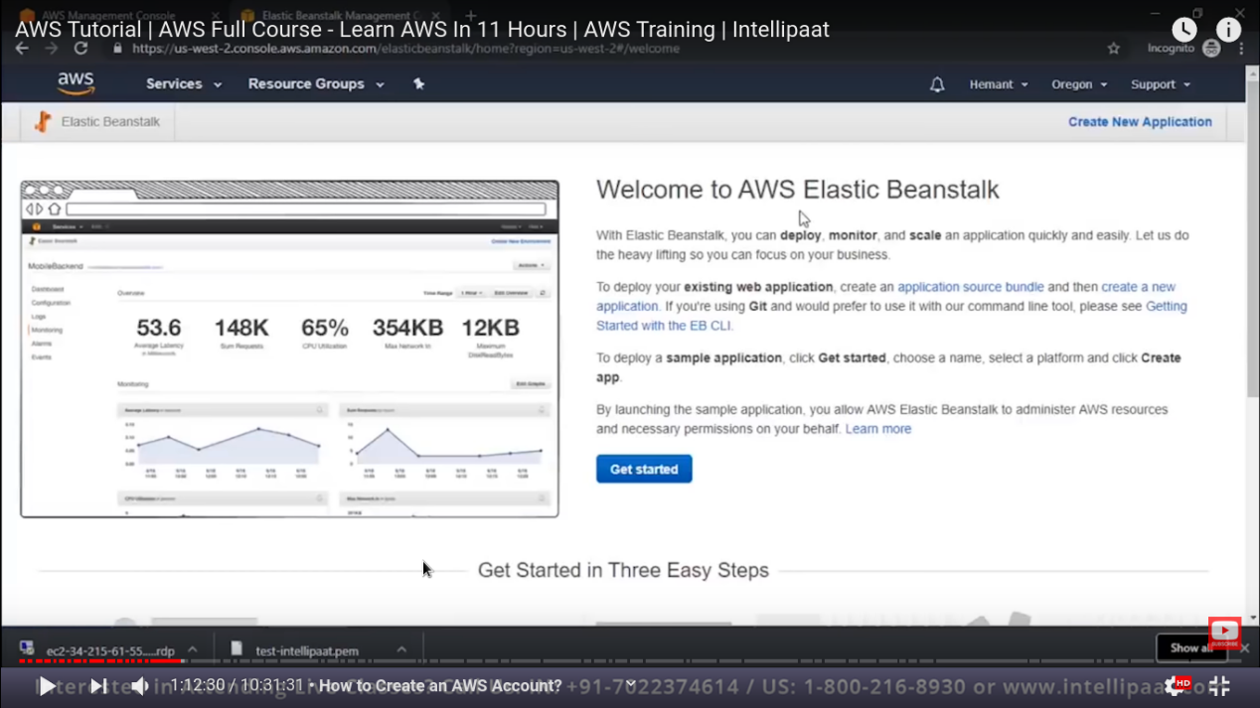

For getting stated for “elastic beanstalk” , we required three things

As listed in this screen shot.

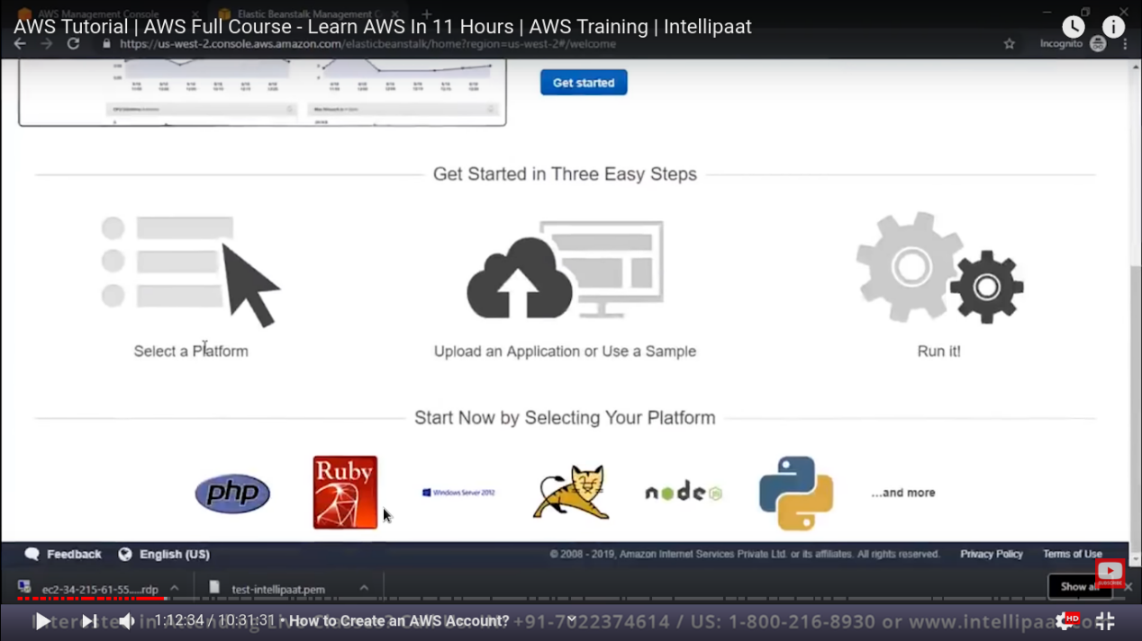

Now click on “get started”

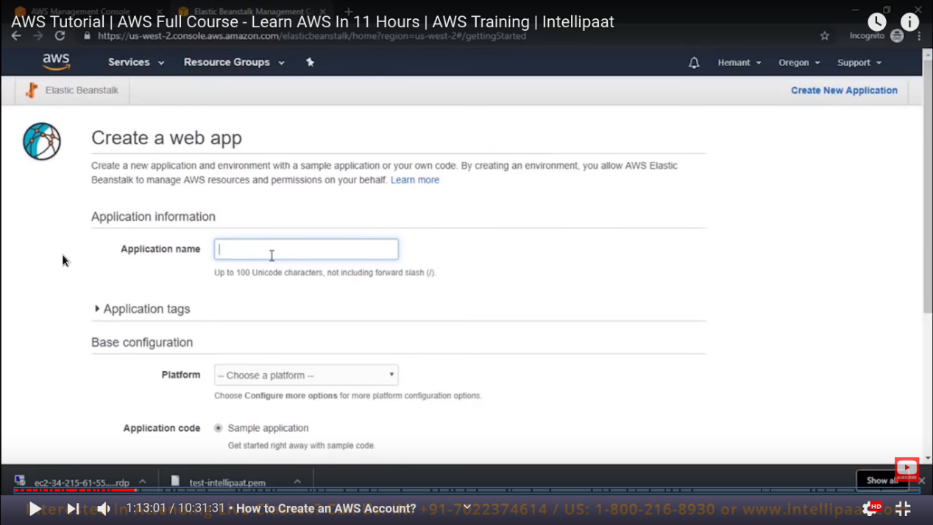

And we can see that we can create a “web application” here.

Give “application name” , then choose platform like -> .NET, php, python and etc.

So by this we are just able to create web server.

We can upload web server file or write our own configuration.

Here we are not able to get access to os.

Just we will get a DashBoard onn which we will upload our website. And this will be hosted for you.

In case of EC2 instance we need to install server and create platform and upload our code to run web site .

But in this case all the things are automatically done and we just need to upload our code this will host our website directly.

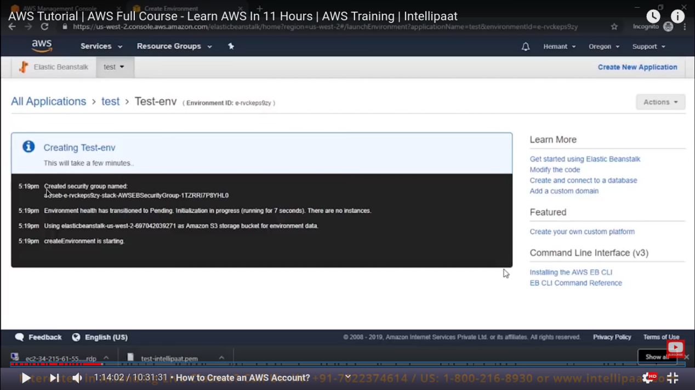

Now our elastic beanstalk is created and there dashboard is like

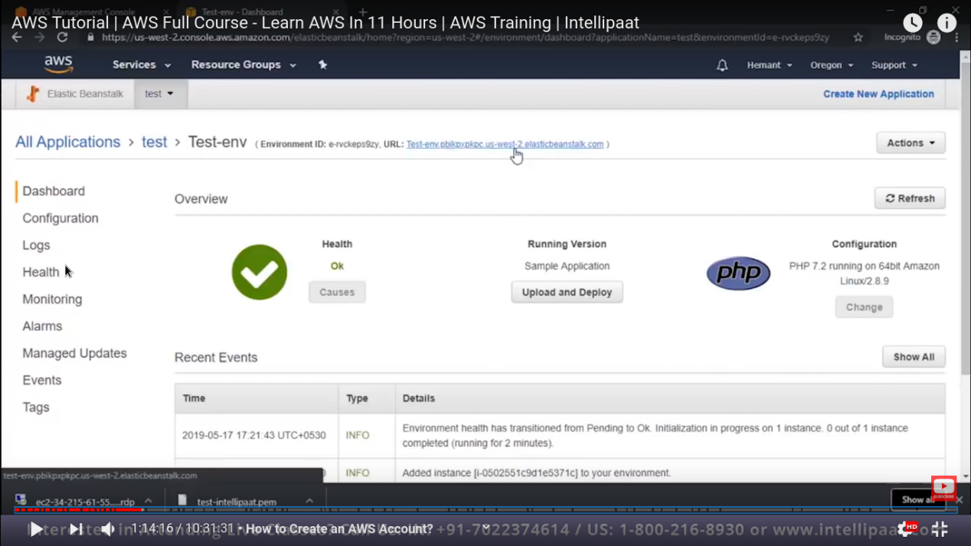

So it is created successfully and healthy as well. And running sample php code as well. why php ?

Because we selected php as our platform.

Imp :- by clicking on the above link as shown in image we are able to go to our webpage/web app.

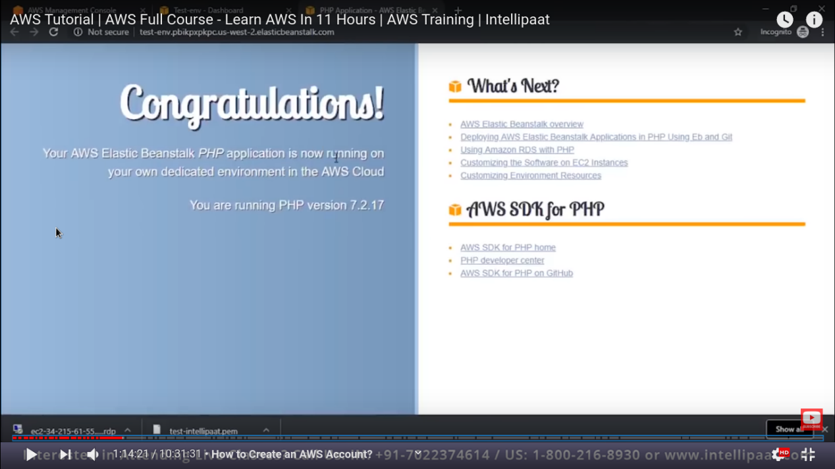

So we do not have control over whole operating system. But we have access to dashboard. Where we can make changes.

Now look at the **Lambda service:-**

So now when we click on the **Lambda** Services

Here is dashboard that we get, this will not host any web app or not an operating function.

Here when you type your code this will give output as text (hello world) or in json format.

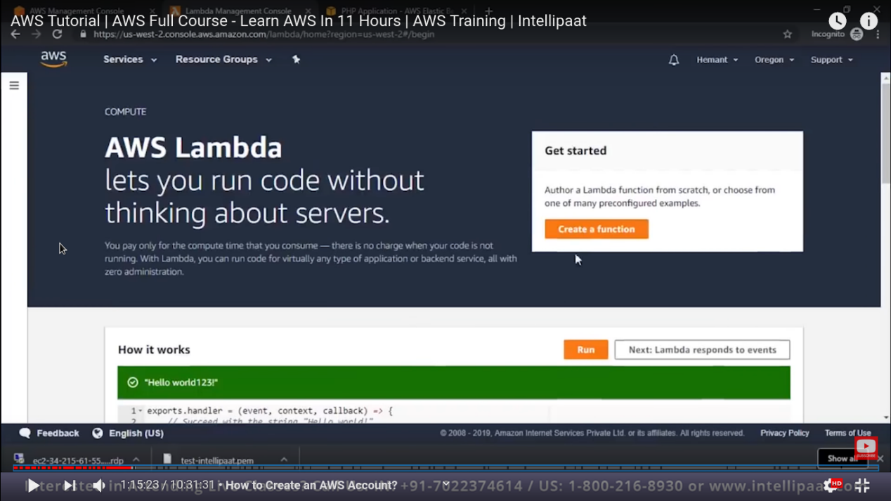

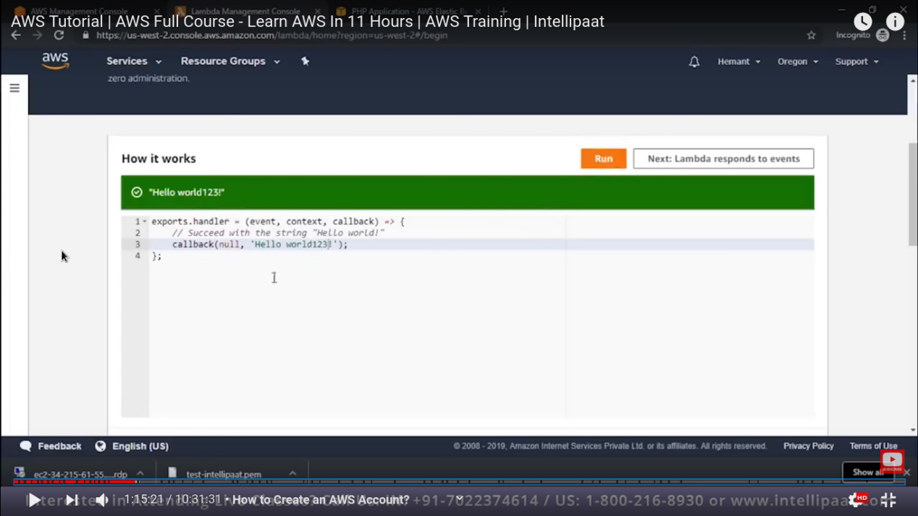

Now if you want to create a function just click on “**create function”**

Storage domain in AWS :-

These are important storage domain in AWS

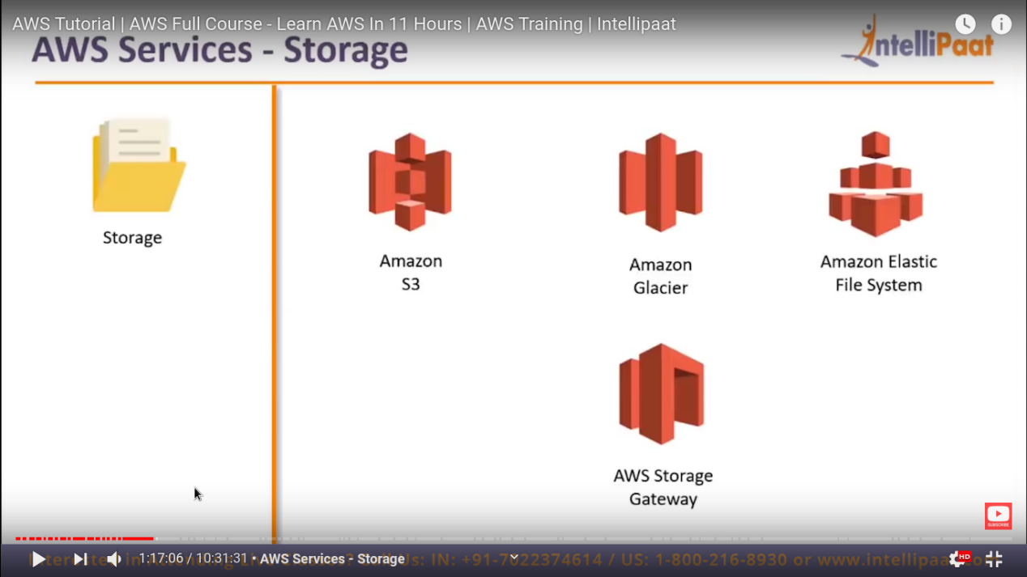

S3 are file storage service. Every file storage is regards as a object.

Object is just like a backend how you store a file.

Each file in S3 bucket is acts like an object.

We can also enable **static** hosting of website from the **bucket** as well.

Now our next service is **amazon glacier** , which is extended service of S3.

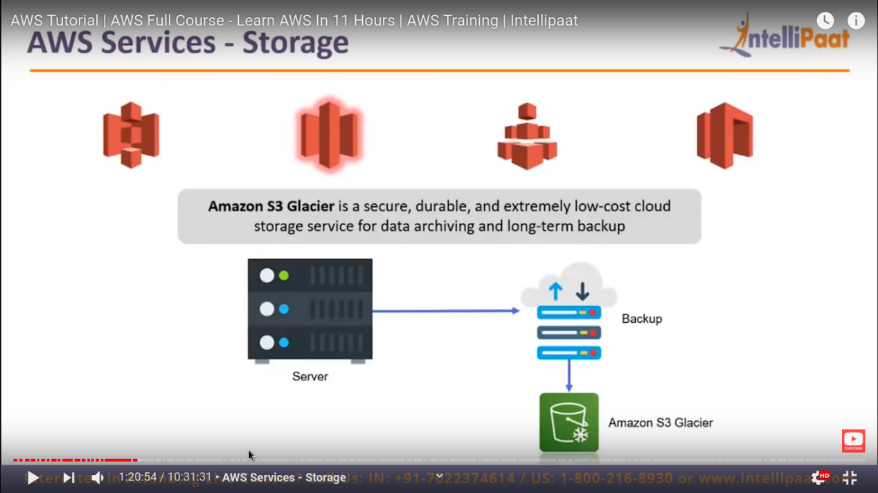

Glacier does not give you direct access it take backup of S3 service.

The folder in S3 is called as bucket. The root folder is called as bucket.

The difference in s3 and glacier is that s3 can retrive you object instantly but glacier take time to retrive. But glacier is cheap so good for backup.

Now next service is “**Amazon Elastic file system (EFS)**”

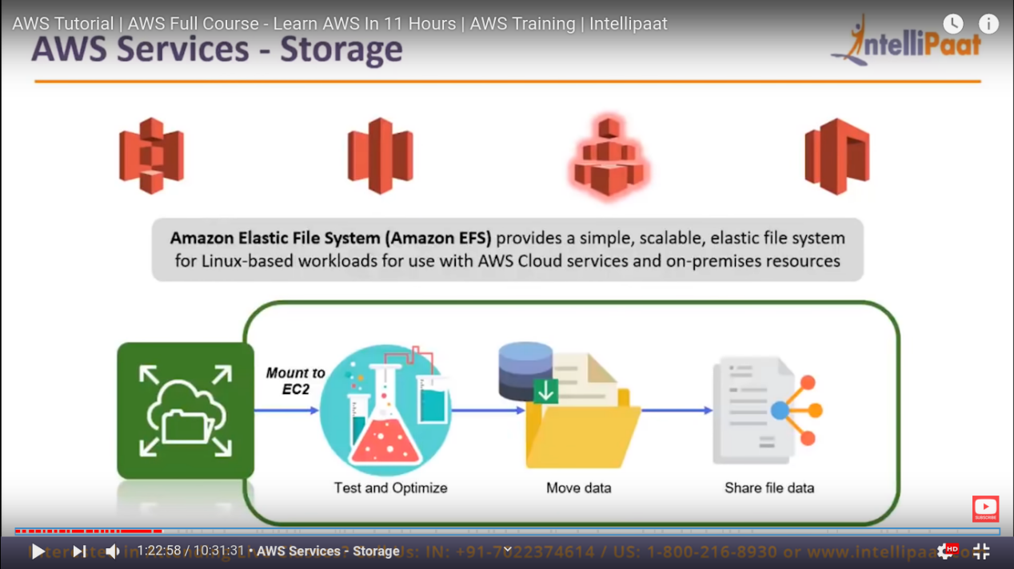

It is storage service but it is different from S3.

So EFS can be mounted on your operating system as volume on any computer on the AWS network.

So this volume can also be shared between multiples computer.

So our next service is **AWS storage Gateway :-**

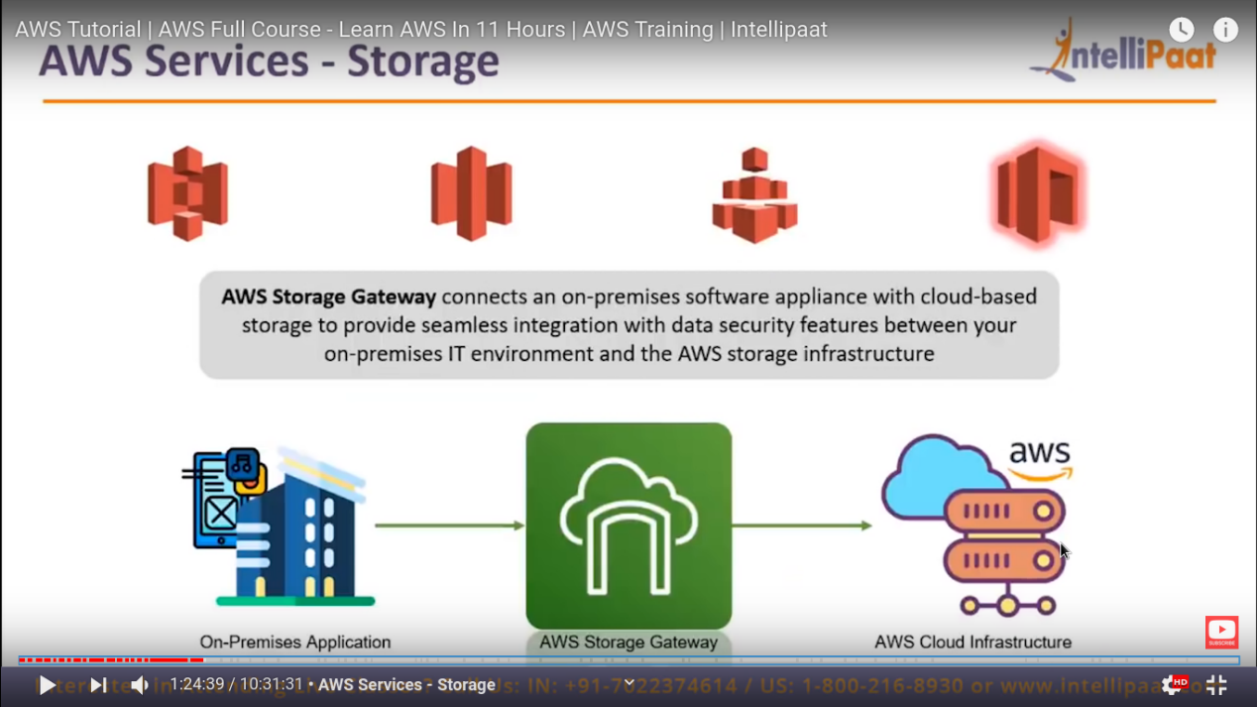

Now it connect your on-premesis computer storage with aws cloud infrastructure.

**Now lets do some hands on**

So go to your management console -> storage -> S3

You will get this kind of dashboard like :-

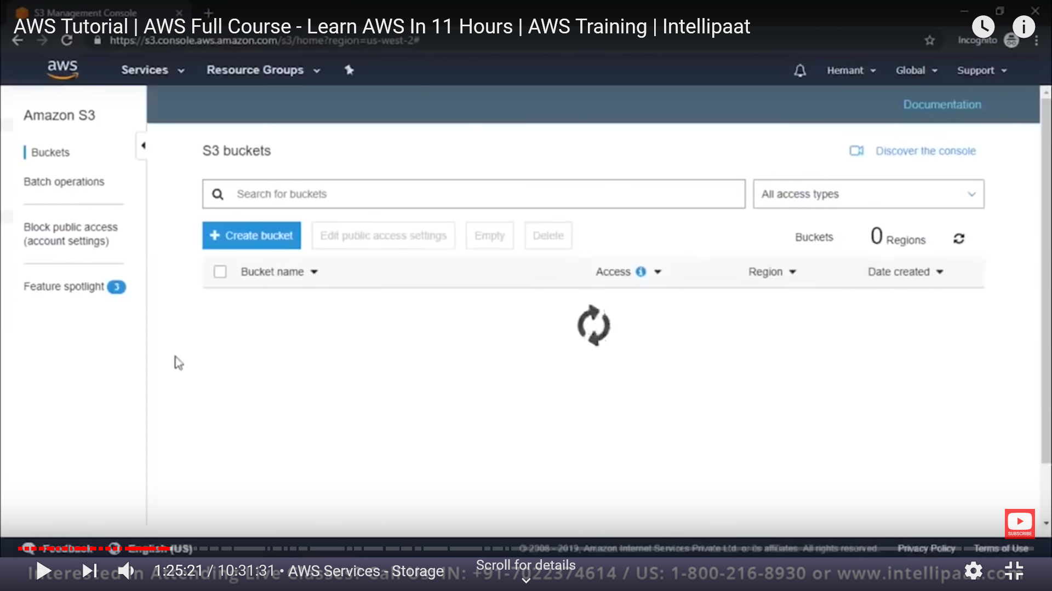

So just click on create bucket.

We know that bucket is nothing but a root folder that contain all the files and every file is denotes as object.

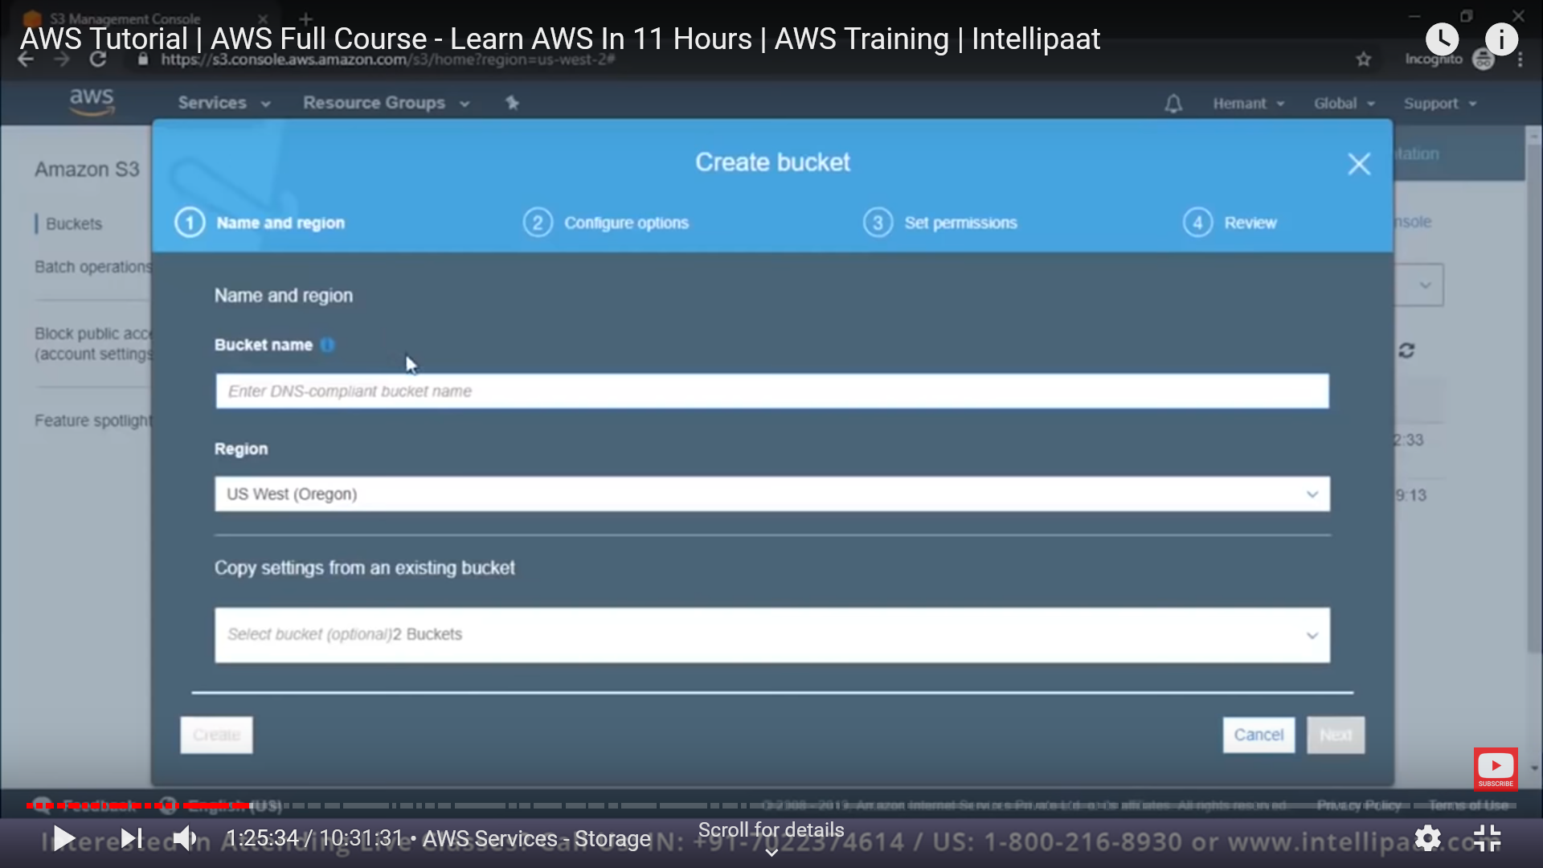

Give bucket name and do next and leave all the things as default.

Do next next . and your bucket is now created and now click on the bucket and go inside it.

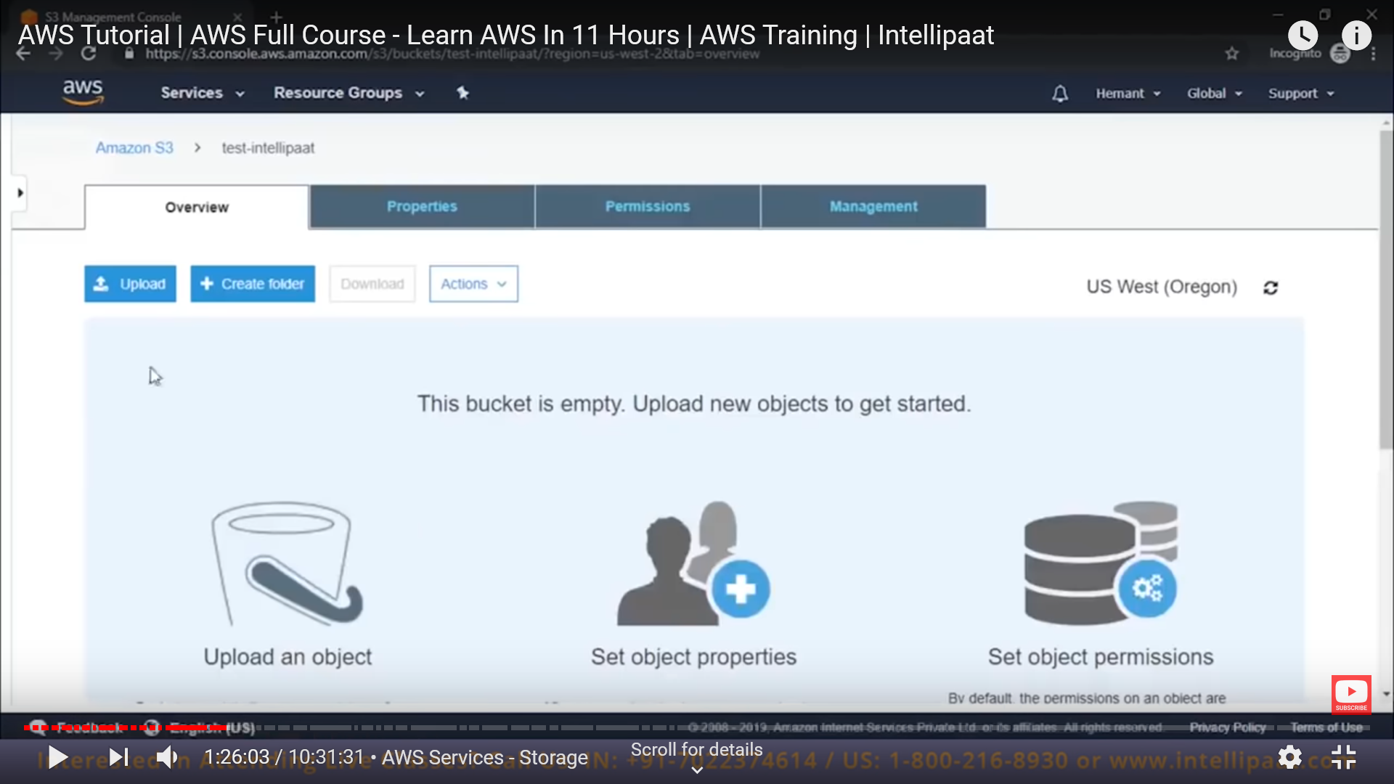

Just upload file like you do in google drive.

And by doing next we can see a window like

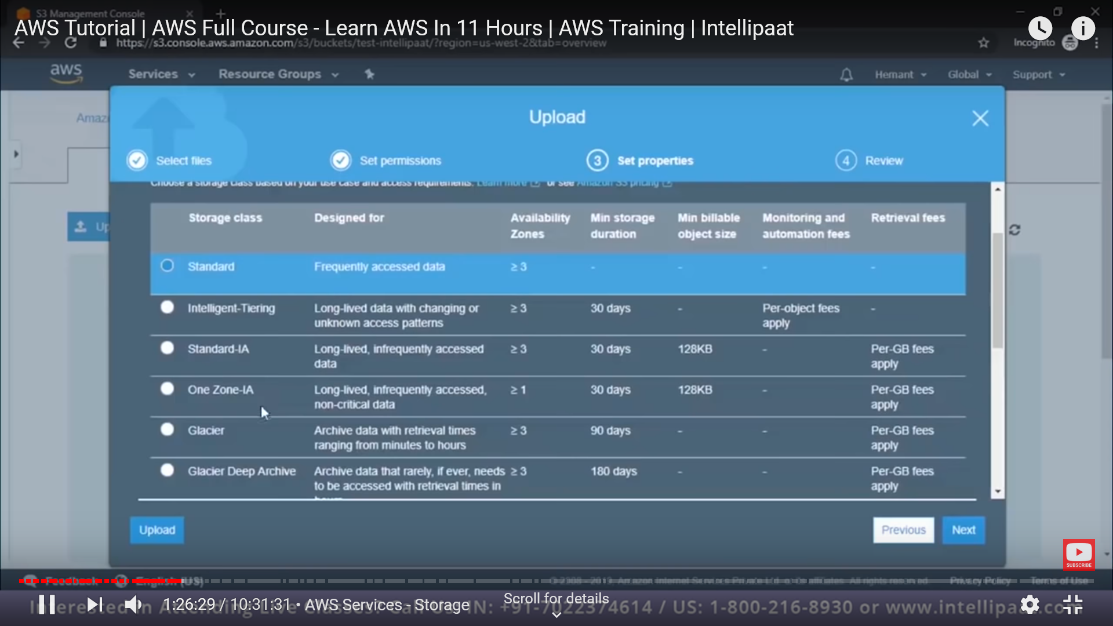

Here we can select that what we need to do for our uploaded file like if we want to make it as standard or we can put that as well in glacier(archive). now select what you want and do next.

Now tick your file that you have just uploaded and you will get some access link. Like

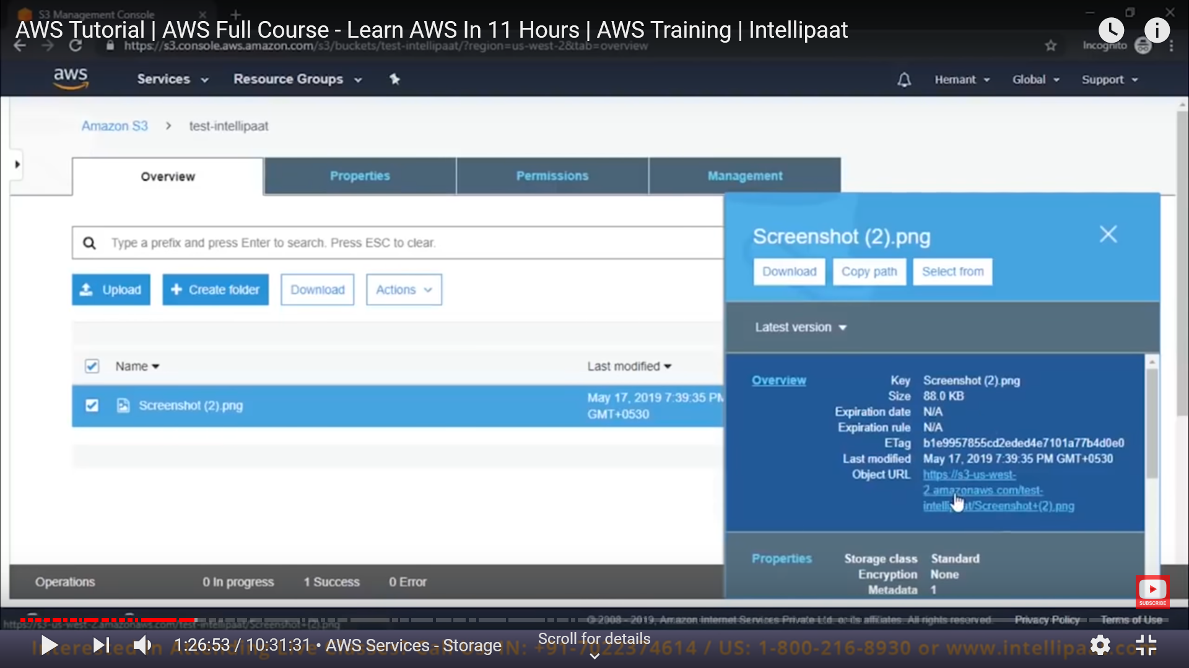

Now click on that access link . -> you will get as permission denied.

Because first we have to make that object as **public**.

Goto permission and at last in public access you will get a notice that “block public setting are turned ON for this bucket”

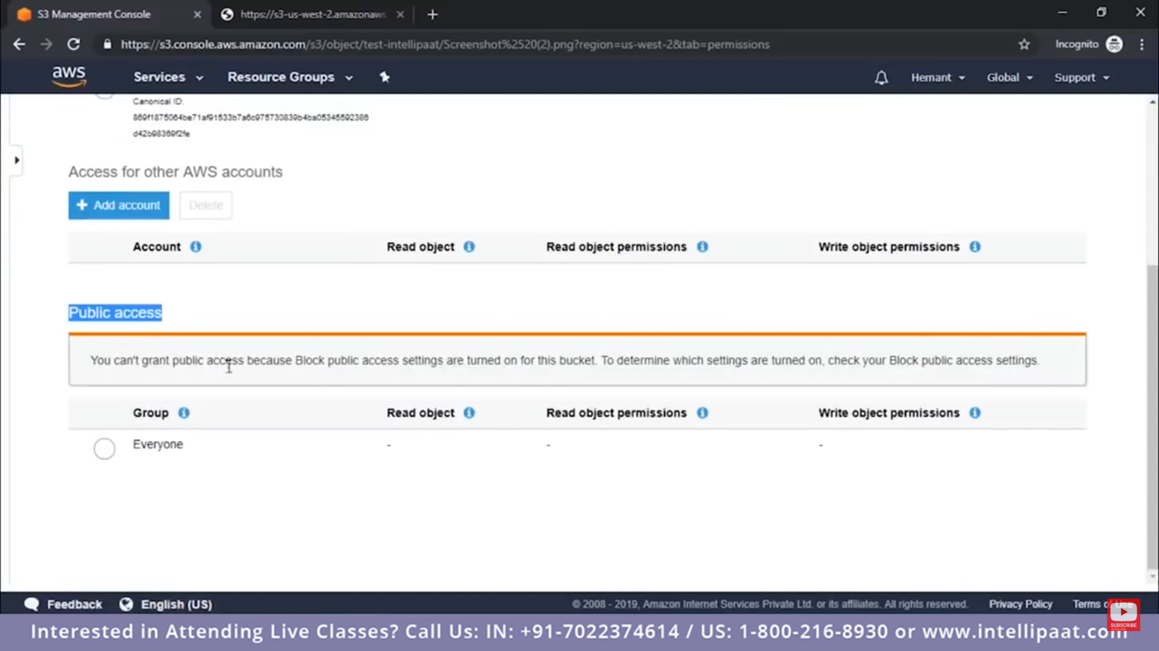

Now go to bucket to make that setting OFF.

Go to bucket permission in by tick , a right side pup up will come here you can click on the permission.

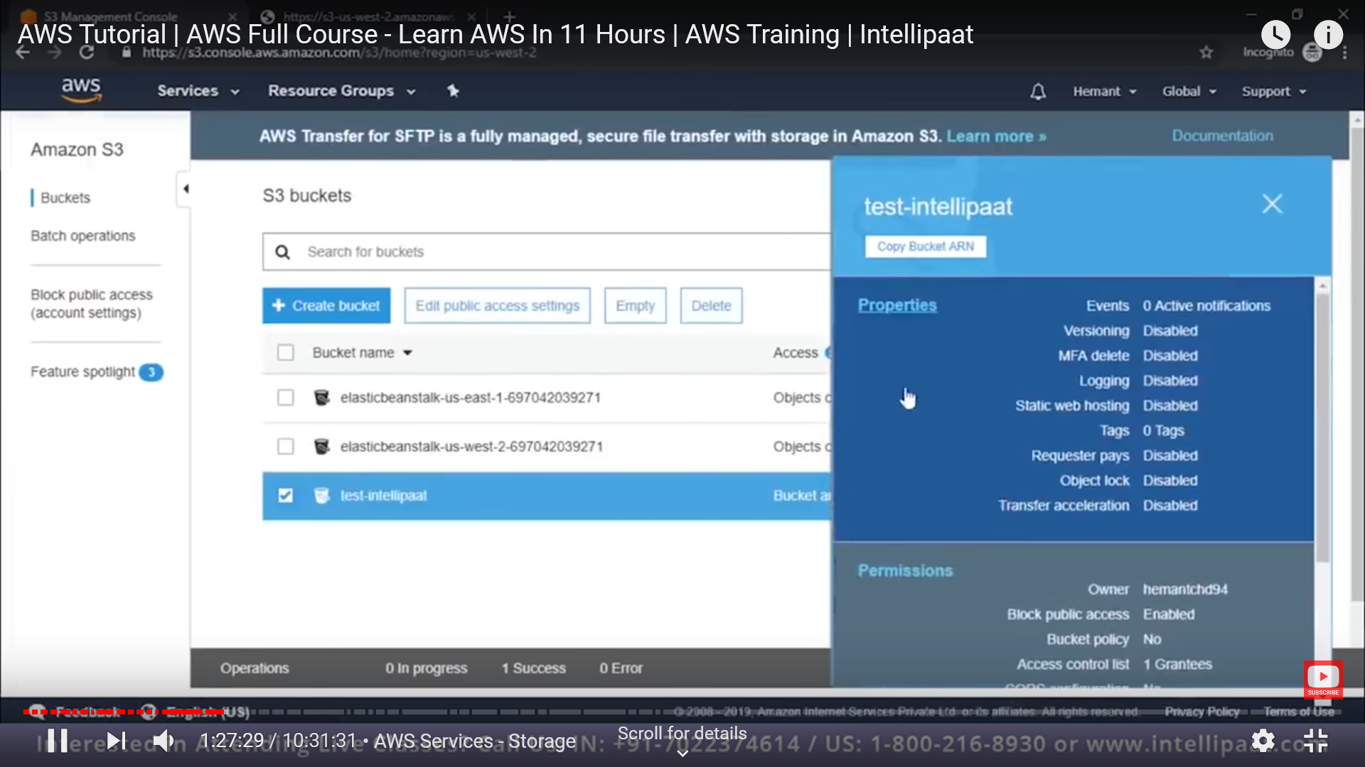

Edit -> untick (block all public option) and save it.

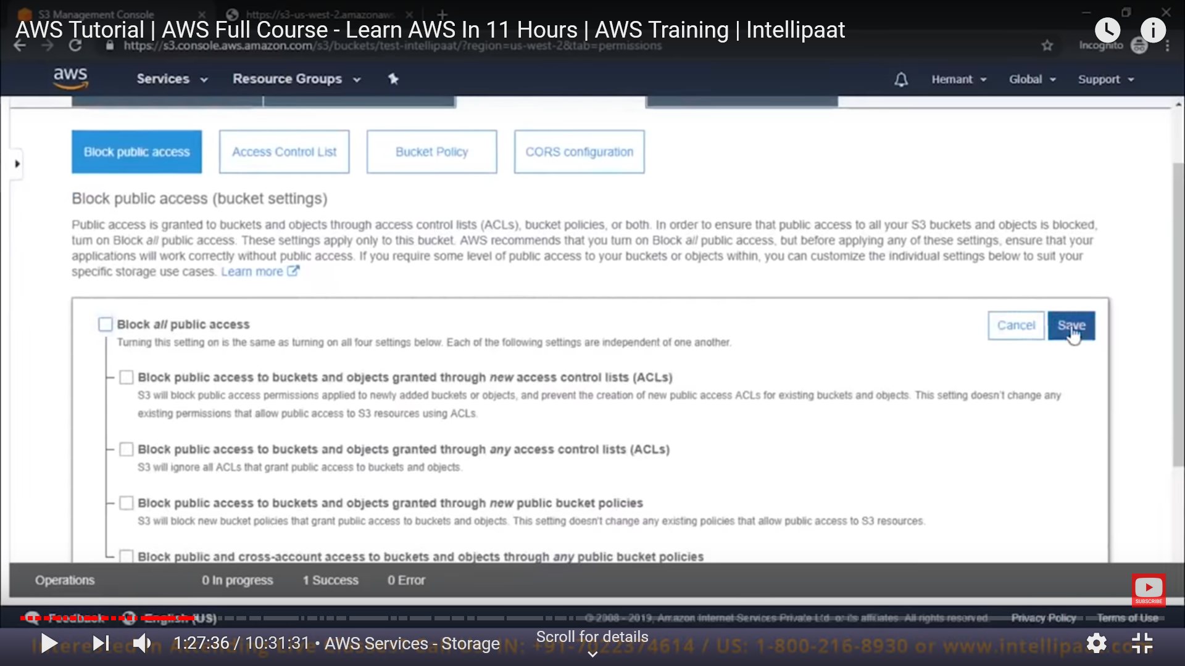

To confirm this setting just type “confirm” and save that.

Now go to your object (like what you have uploaded) -> tick it -> right pop up will come and click on the permission and and grant access to everyone.

And now click on that link. Now any body which have that link can access to that uploaded file.

We can also embedded this image (upload file) link to your website to use that image.

This is how we can read form S3.

**Now go to EFS demo. -> go to AWS Management console and click on the EFS .**

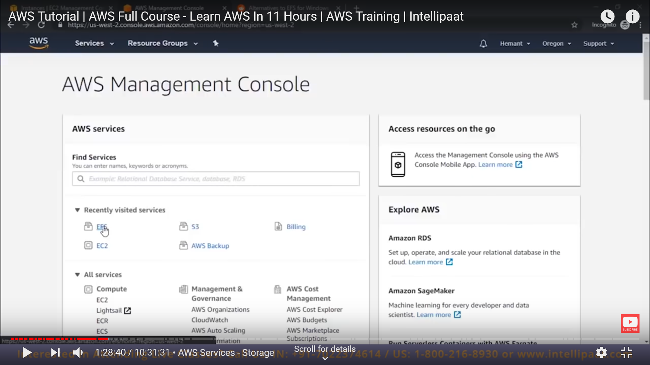

Now we have an option to create a File System.

What is Amazon VPC?

Amazon Virtual Private Cloud (Amazon VPC) enables you to launch AWS resources into a virtual network that you've defined. This virtual network closely resembles a traditional network that you'd operate in your own data center, with the benefits of using the scalable infrastructure of AWS.

Or simply,

VPC -> A virtual network dedicated to your AWS account.

Now when we create a EFS ->we need to mention VPC, select same vpc network to which we want to create our file system.

So it should be the same vpc to which our instance to be mount.

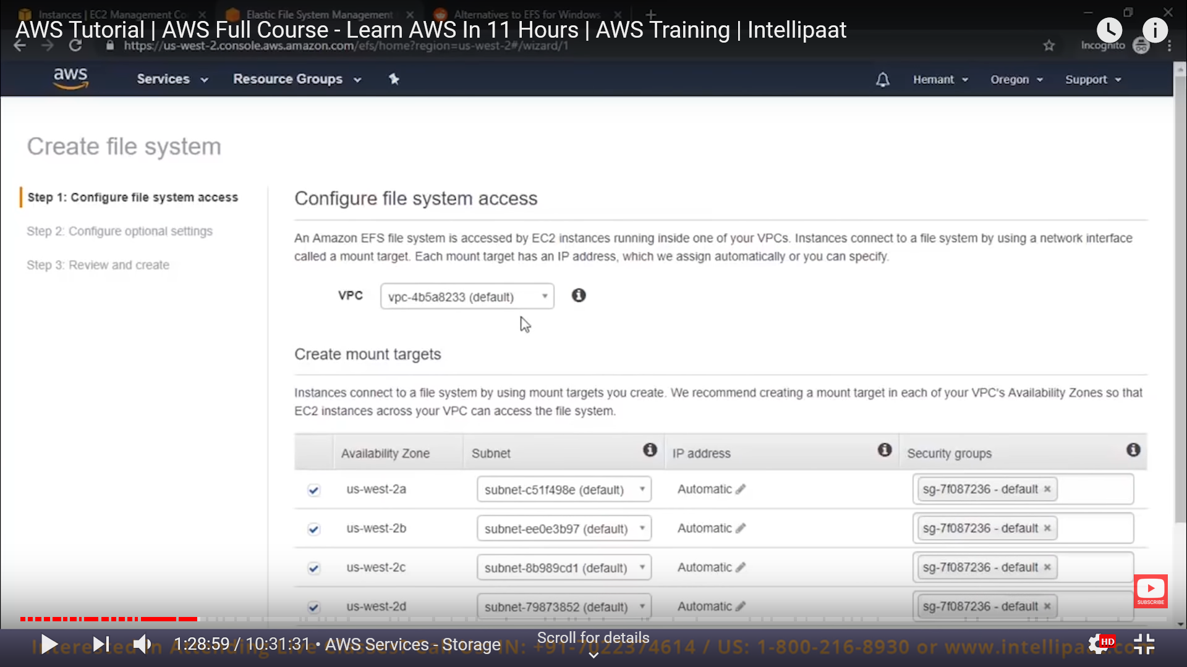

Do next next and leave every things as default and create our filesystem.

Now our file system is create and Security group should be same for our EC2 as well.

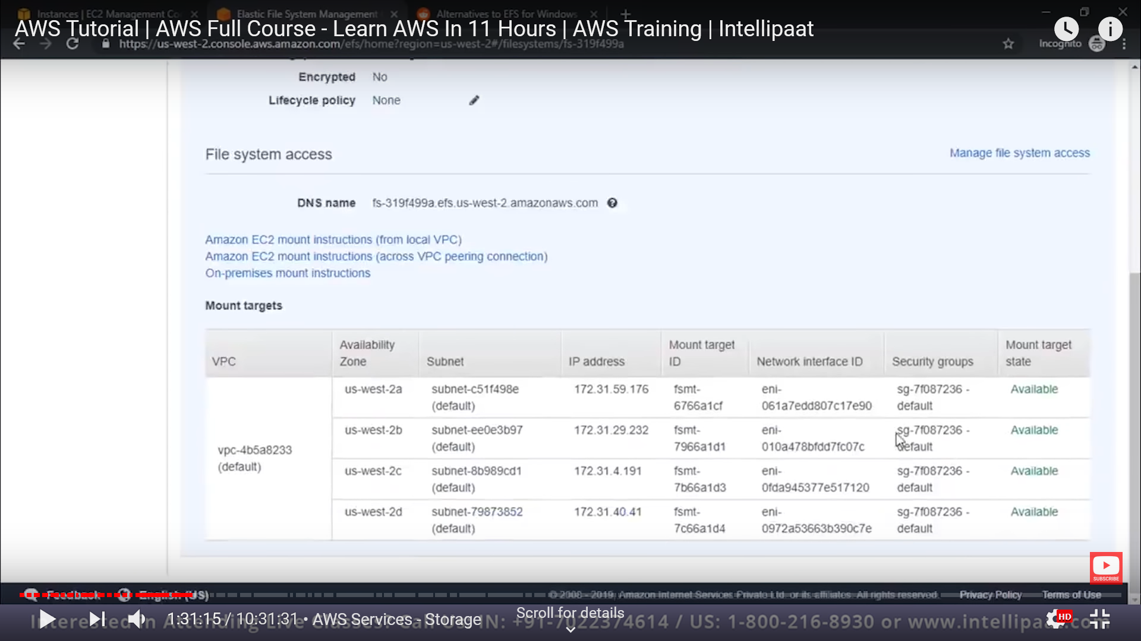

Here we can see our security group. This table will come on EFS section .

Now we have two ubuntu instance running lets say ubuntu1 and ubuntu2 also we have done ssh to these instance using our putty session.

Now we are doing is that we have to connect our EFS mount point to ubuntu instances.

Firstly we need to ensure that both of our instance are on same security group.

If it is not same we need to go to our instance -> action -> networking -> change security group.

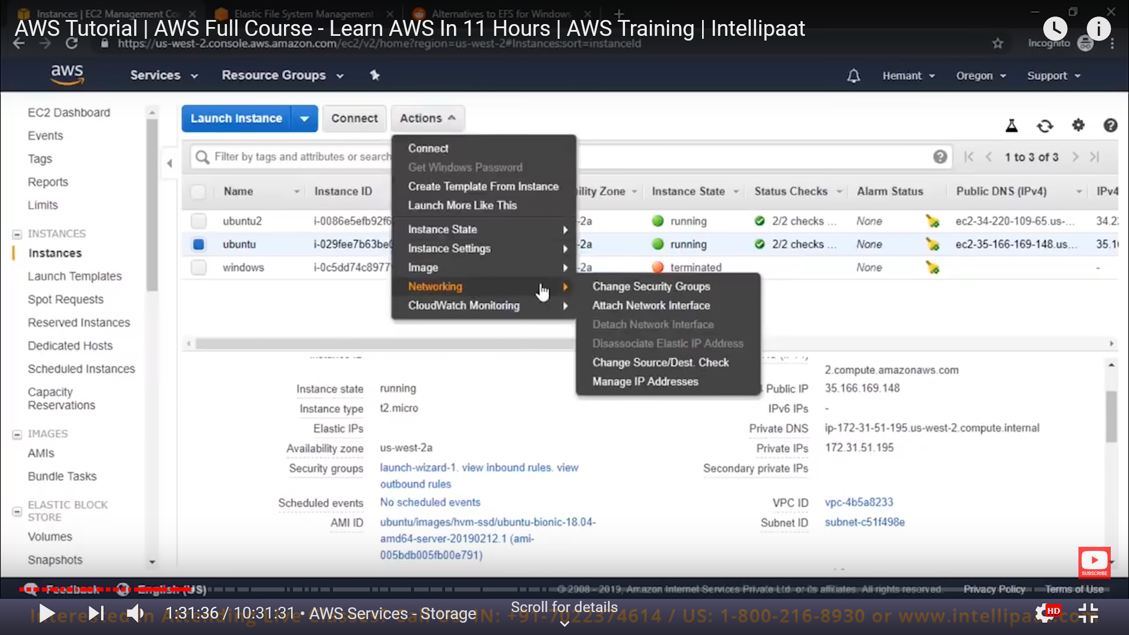

Select same security groups, from here

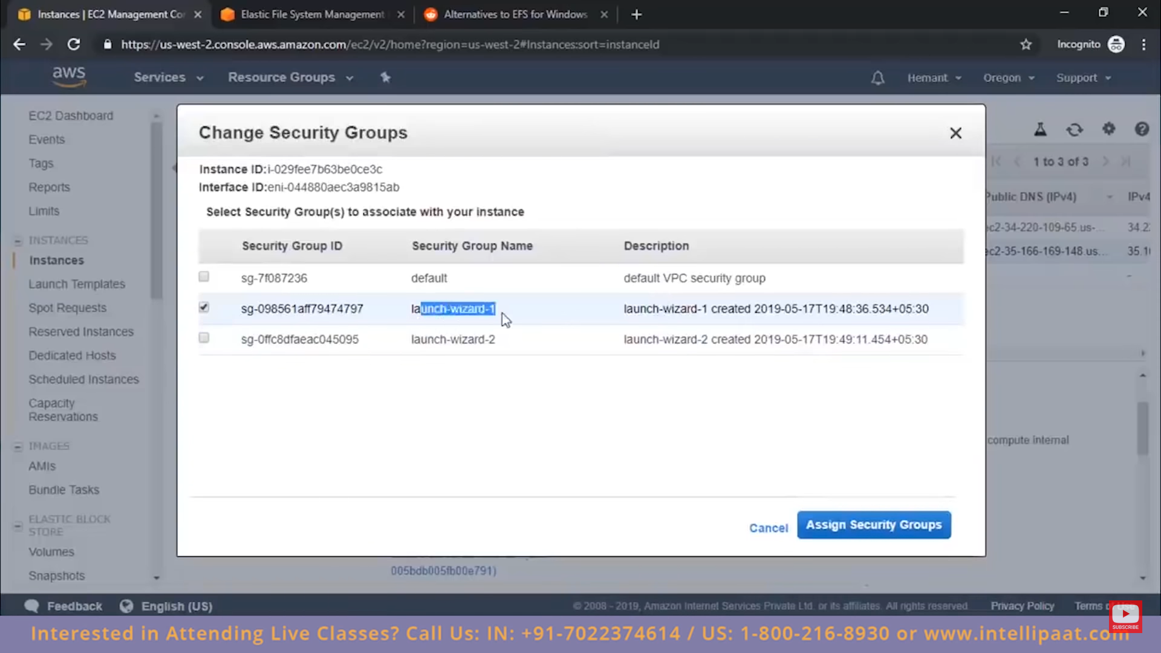

We can select mutiple security group as well.

Now both of our instance are connected to same security group as same as for EFS.

Now we need to follow some set of instruction which come when we click on the link as

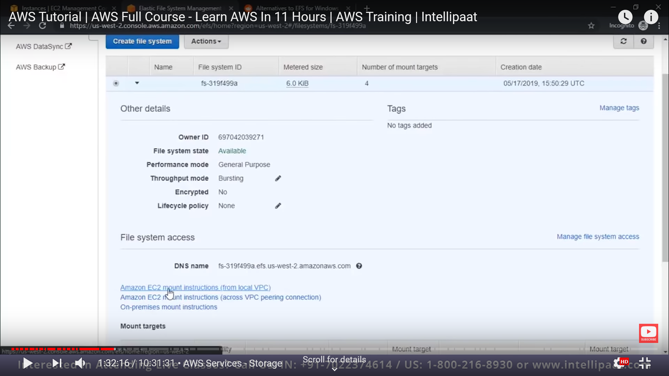

These are the set of instruction :-

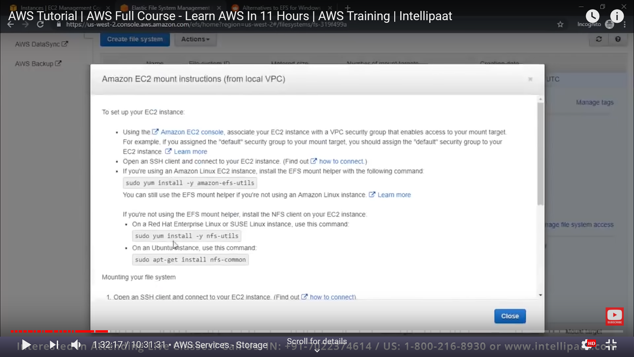

First update our ubuntu instances

Second then install “nfs-utiils” pakage as mention in above picture.

Third now make a folder to which we need to mount our nfs.

Fourth copy this command as mention in the document as

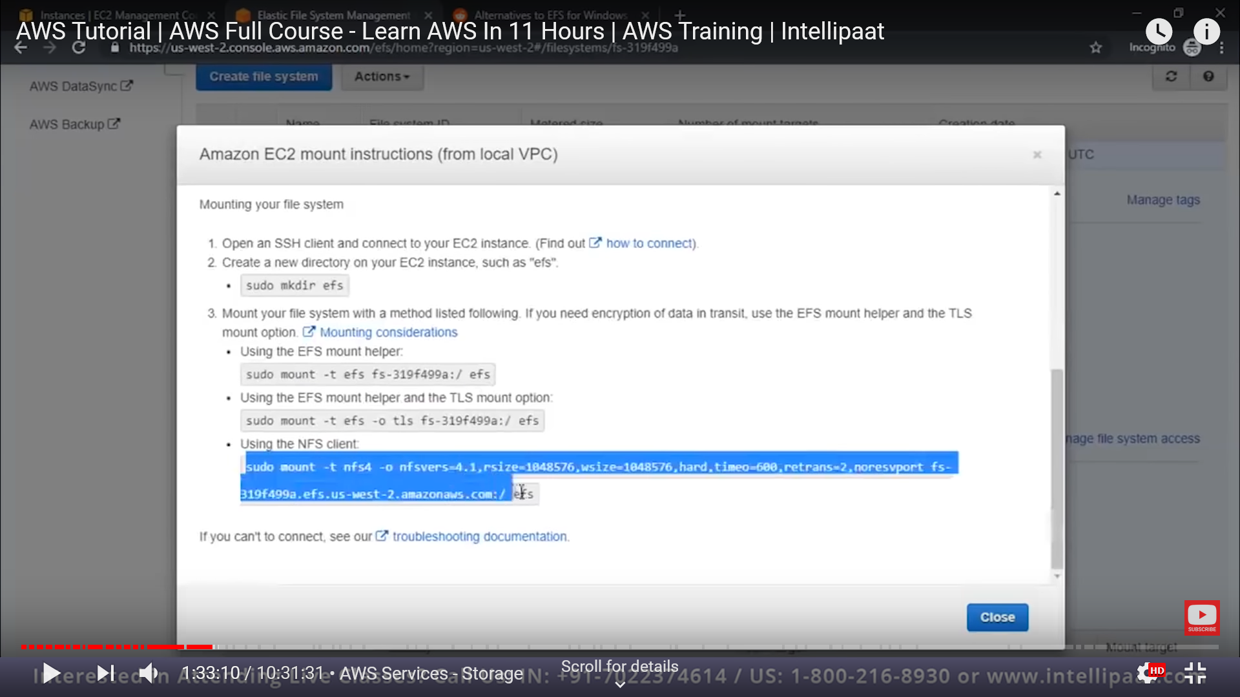

And run that commad by adding folder name as well. Like

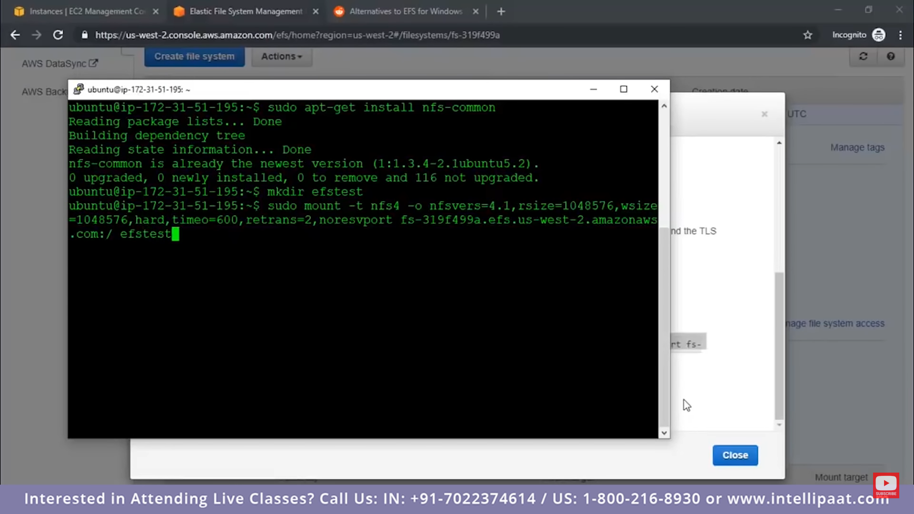

Here “efstest” is our directory name that we created in third step.

Now do same thing on our secong ubuntu instance.

Now when we create a file/folder in this mounted folder form first instance, we can see same reflected on our second instance as well.

That means this is shared volume.

So this is how efs works , it acts like same file between multiple instances.

Now lets switch to other service as well which is “database service”.

Lets see that in next part -4